Perfect Competition Stage 3 Analysis

Stage 3 Analysis

Analysis
The model showed that my hypothesis for a 9/11/29 allocation differed from the farm model. The model showed that the optimal allocation was 10 tomatoes, 20 carrots, and 30 mesclun. Furthermore, the model used 60 beds out of the 64 available beds. The season profit of $42,762 closely matches with the model’s season profit of $42,775.16, with a difference of $13.16, possibly due to input precision or rounding. The farm plan guides the farmer in allocating resources to maximize profits and indicates when to stop adding beds once marginal costs exceed marginal revenue. Figure 1 shows the Solver’s optimal crop allocation, season profit, and the status of the farm’s constraints.
Figure 1. Solver Optimal Farm Allocation
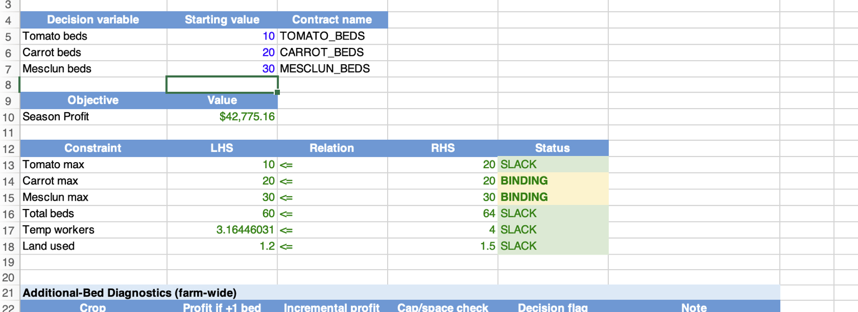
The farmer should stop growing additional tomatoes after 10 beds because marginal profit declines due to higher costs. The marginal profit from growing the 10th bed is approximately $551. The marginal profit from growing the 11th bed is approximately −$591. In perfect competition, the farmer cannot control prices because the farmer is a price taker. The farmer should continue adding production while marginal revenue is greater than marginal cost. As shown in Figure 2, the marginal profit becomes negative with the 11th tomato bed when marginal cost exceeds marginal revenue.

Figure 2. Tomato Standalone Marginal Analysis
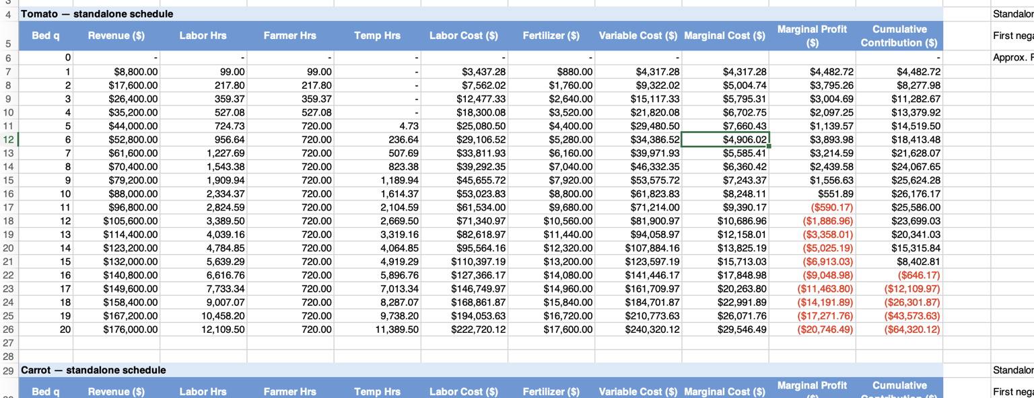
The tomato marginal cost is reduced when growing the 6th bed due to increased utilization of temporary labor after the farmer has exhausted the 720-hour work limit. While the labor hours worked increase, temporary workers are paid at a lower wage, resulting in lower marginal cost for the 6th bed. This decrease in marginal cost can also be seen in Figure 2, where marginal cost falls from $7,660.43 for the 5th bed to $4,906.02 for the 6th bed.
The Solver stops growing carrots at 20 beds and mesclun at 30 beds due to binding constraints. The tomato constraint is slack, but growing beyond 10 beds results in negative marginal profit. Given shadow values of approximately $352 for carrots and $246 for mesclun, if these constraints were relaxed, growing one additional unit of carrots beyond 20 beds would result in approximately $352 in additional profit. This is approximately $106 more than the marginal value of relaxing the mesclun constraint.
It would still make economic sense to grow a crop provided that its marginal revenue is not less than its marginal cost. If MR > MC, then plant the additional bed but if MR < MC, then do not plant the additional bed . Fixed costs need to be paid whether crops are grown. If the crops generate money after subtracting variable costs from revenue, that contribution margin can be used to help pay the fixed costs.
My hypothesis of 9 tomatoes, 11 carrots, and 29 mesclun differed from the farm model because I was focused on the costs associated with expanding the crop beds. This made me hesitant about expanding the farm beds and resulted in a reduced allocation of crops, such as recommending 11 carrot beds versus Solver’s 20 beds. Using marginal analysis clarified the marginal revenue versus marginal cost relationship when growing additional crops. On the surface, the higher costs made me hesitant to expand production, but recognizing when marginal revenue is greater than marginal cost provides guidance that growing more could be profitable. Had I followed my hypothesis of growing only 11 carrot beds, I would have missed the opportunity to maximize profits.

